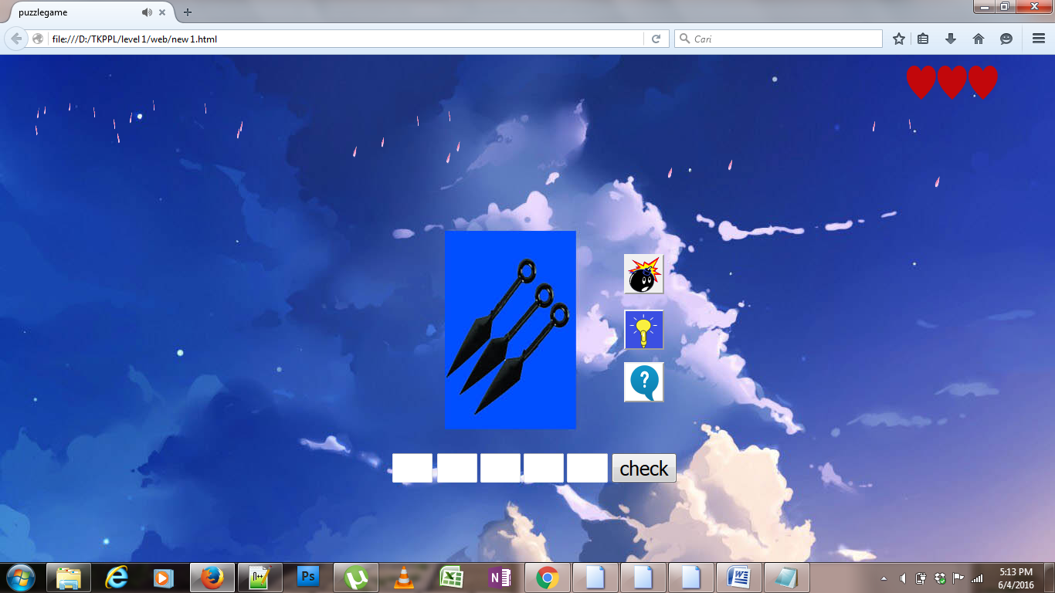

<html>

<title>puzzlegame</title>

<head>

<style type="text/css">

.st{

margin:20px;

margin-top:50px;

margin-left:500px;

font-size:25;

}

.du{

margin-left:-18px;

font-size:25;

}

.ti{

font-size:25;

}

.em{

font-size:25;

}

.li{

font-size:25;

}

.love{

width:50px;

height:50px;

margin-left:1160px;

}

.love1{

width:50px;

height:50px;

margin-left:1200px;

margin-top:-50px;

}

.love2{

width:50px;

height:50px;

margin-left:1240px;

margin-top:-50px;

}

.sz{

font-size:25;

}

.unit{

animation:snow 20s infinite;

position:absolute;

top:-10px;

display:block;

}

@keyframes snow{

from{top:-10px;left:1200px;transform:rotatey(90deg);}

to{top:1300px;left:1100px;transform:rotatey(180deg);}

}

.unit2{

animation:snow1 21s infinite;

position:absolute;

top:-10px;

display:block;

}

@keyframes snow1{

from{top:-10px;left:800px;transform:rotatey(90deg);}

to{top:1300px;left:1200px;transform:rotatey(180deg);}

}

.unit3{

animation:snow2 22s infinite;

position:absolute;

top:-10px;

display:block;

}

@keyframes snow2{

from{top:-10px;left:900px;transform:rotatey(90deg);}

to{top:1300px;left:1100px;transform:rotatey(180deg);}

}

.unit4{

animation:snow3 23s infinite;

position:absolute;

top:-10px;

display:block;

}

@keyframes snow3{

from{top:-10px;left:500px;transform:rotatey(90deg);}

to{top:1300px;left:1100px;transform:rotatey(180deg);}

}

.unit5{

animation:snow4 24s infinite;

position:absolute;

top:-10px;

display:block;

}

@keyframes snow4{

from{top:-10px;left:400px;transform:rotatey(90deg);}

to{top:1300px;left:800px;transform:rotatey(180deg);}

}

.unit6{

animation:snow5 25s infinite;

position:absolute;

top:-10px;

display:block;

}

@keyframes snow5{

from{top:-10px;left:600px;transform:rotatey(90deg);}

to{top:1300px;left:200px;transform:rotatey(180deg);}

}

.unit7{

animation:snow6 26s infinite;

position:absolute;

top:-10px;

display:block;

}

@keyframes snow6{

from{top:-10px;left:500px;transform:rotatey(90deg);}

to{top:1300px;left:100px;transform:rotatey(180deg);}

}

.unit8{

animation:snow7 27s infinite;

position:absolute;

top:-10px;

display:block;

}

@keyframes snow7{

from{top:-10px;left:100px;transform:rotatey(90deg);}

to{top:1300px;left:500px;transform:rotatey(180deg);}

}

.unit9{

animation:snow8 28s infinite;

position:absolute;

top:-10px;

display:block;

}

@keyframes snow8{

from{top:-10px;left:300px;transform:rotatey(90deg);}

to{top:1300px;left:50px;transform:rotatey(180deg);}

}

.unit10{

animation:snow9 29s infinite;

position:absolute;

top:-10px;

display:block;

}

@keyframes snow9{

from{top:-10px;left:10px;transform:rotatey(90deg);}

to{top:1300px;left:200px;transform:rotatey(180deg);}

}

.unit11{

animation:snow10 30s infinite;

position:absolute;

top:-10px;

display:block;

}

@keyframes snow10{

from{top:-10px;left:300px;transform:rotatey(90deg);}

to{top:1300px;left:80px;transform:rotatey(180deg);}

}

.unit12{

animation:snow11 31s infinite;

position:absolute;

top:-10px;

display:block;

}

@keyframes snow11{

from{top:-10px;left:100px;transform:rotatey(90deg);}

to{top:1300px;left:500px;transform:rotatey(180deg);}

}

.unit13{

animation:snow12 32s infinite;

position:absolute;

top:-10px;

display:block;

}

@keyframes snow12{

from{top:-10px;left:500px;transform:rotatey(90deg);}

to{top:1300px;left:800px;transform:rotatey(180deg);}

}

.unit14{

animation:snow13 33s infinite;

position:absolute;

top:-10px;

display:block;

}

@keyframes snow13{

from{top:-10px;left:150px;transform:rotatey(90deg);}

to{top:1300px;left:40px;transform:rotatey(180deg);}

}

.unit15{

animation:snow14 34s infinite;

position:absolute;

top:-10px;

display:block;

}

@keyframes snow14{

from{top:-10px;left:550px;transform:rotatey(90deg);}

to{top:1300px;left:700px;transform:rotatey(180deg);}

}

.unit16{

animation:snow15 35s infinite;

position:absolute;

top:-10px;

display:block;

}

@keyframes snow15{

from{top:-10px;left:20px;transform:rotatey(90deg);}

to{top:1300px;left:100px;transform:rotatey(180deg);}

}

.unit17{

animation:snow16 36s infinite;

position:absolute;

top:-10px;

display:block;

}

@keyframes snow16{

from{top:-10px;left:100px;transform:rotatey(90deg);}

to{top:1300px;left:30px;transform:rotatey(180deg);}

}

.unit18{

animation:snow17 37s infinite;

position:absolute;

top:-10px;

display:block;

}

@keyframes snow17{

from{top:-10px;left:25px;transform:rotatey(90deg);}

to{top:1300px;left:200px;transform:rotatey(180deg);}

}

.unit19{

animation:snow18 38s infinite;

position:absolute;

top:-10px;

display:block;

}

@keyframes snow18{

from{top:-10px;left:250px;transform:rotatey(90deg);}

to{top:1300px;left:40px;transform:rotatey(180deg);}

}

.unit20{

animation:snow19 39s infinite;

position:absolute;

top:-10px;

display:block;

}

@keyframes snow19{

from{top:-10px;left:60px;transform:rotatey(90deg);}

to{top:1300px;left:180px;transform:rotatey(180deg);}

}

.unit21{

animation:snow20 40s infinite;

position:absolute;

top:-10px;

display:block;

}

@keyframes snow20{

from{top:-10px;left:180px;transform:rotatey(90deg);}

to{top:1300px;left:30px;transform:rotatey(180deg);}

}

.unit22{

animation:snow21 30s infinite;

position:absolute;

top:-10px;

display:block;

}

@keyframes snow21{

from{top:-10px;left:1100px;transform:rotatey(90deg);}

to{top:1300px;left:1200px;transform:rotatey(180deg);}

}

.unit23{

animation:snow22 31s infinite;

position:absolute;

top:-10px;

display:block;

}

@keyframes snow22{

from{top:-10px;left:1150px;transform:rotatey(90deg);}

to{top:1300px;left:1210px;transform:rotatey(180deg);}

}

.sq{

background-image:url("bomb.png");

width:52px;

height:52px;

margin-left:800px;

margin-top:200px;

}

.sa{

background-image:url("hint1.png");

width:52px;

height:52px;

margin-left:800px;

margin-top:4px;

}

.so{

background-image:url("info.png");

width:52px;

height:52px;

margin-left:800px;

}

</style>

<script language="javascript">

function check(form)

{

if(form.satu.value=="k"&& form.dua.value=="u" && form.tiga.value=="n" && form.empat.value=="a" && form.lima.value=="i")

{

alert("iya,benar sekali.Kunai ini merupakan senjata dari sebuah film yang dinamakan naruto")

location="stage.html"

}

else if(form.satu.value!="k"||form.dua.value!="u"||form.tiga.value!="n"||form.empat.value!="a"||form.lima.value!="i")

{

{alert("Salah")

form.satu.value="";

form.dua.value="";

form.tiga.value="";

form.empat.value="";

form.lima.value="";

}

}

}

function tekan(form)

{alert("your hint just get one,one letter")

document.getElementById('ui').value='k';

document.getElementById("myi").style.display = "none";

if(document.getElementById("myi").style.display == "none")

{

document.getElementById("buto").disabled = "true";

document.getElementById("buto1").disabled = "true";

document.getElementById("bto").disabled = "true";

}

}

function tekan1(form)

{alert("your hint just get two")

document.getElementById('ui').value='k';

document.getElementById('ha').value='n';

document.getElementById("myi").style.display = "none";

document.getElementById("hst").style.display = "none";

if(document.getElementById("hst").style.display == "none" && document.getElementById("myi").style.display == "none")

{

document.getElementById("bto").disabled = "true";

document.getElementById("buto1").disabled = "true";

document.getElementById("buto").disabled = "true";

}

}

function tekan2(form)

{alert("this is the answer")

document.getElementById('ui').value='k';

document.getElementById('hi').value='u';

document.getElementById('ha').value='n';

document.getElementById('hu').value='a';

document.getElementById('he').value='i';

document.getElementById("myi").style.display = "none";

document.getElementById("hst").style.display = "none";

document.getElementById("ese").style.display = "none";

alert("game over!!!!")

document.getElementById('ui').value='';

document.getElementById('hi').value='';

document.getElementById('ha').value='';

document.getElementById('hu').value='';

document.getElementById('he').value='';

document.getElementById("myi").style.display = "";

document.getElementById("hst").style.display = "";

document.getElementById("ese").style.display = "";

}

</script>

</head>

<body background="bg11.jpg" max-width="100px" min-height="-100px">

<div class="unit">

<img src="sakura.png" width="50" height="50"></div>

<div class="unit2">

<img src="sakura.png" width="50" height="50"></div>

<div class="unit3">

<img src="sakura.png" width="50" height="50"></div>

<div class="unit4">

<img src="sakura.png" width="50" height="50"></div>

<div class="unit5">

<img src="sakura.png" width="50" height="50"></div>

<div class="unit6">

<img src="sakura.png" width="50" height="50"></div>

<div class="unit7">

<img src="sakura.png" width="50" height="50"></div>

<div class="unit8">

<img src="sakurae.png" width="50" height="50"></div>

<div class="unit9">

<img src="sakura.png" width="50" height="50"></div>

<div class="unit10">

<img src="sakurae.png" width="50" height="50"></div>

<div class="unit11">

<img src="sakura.png" width="50" height="50"></div>

<div class="unit12">

<img src="sakurae.png" width="50" height="50"></div>

<div class="unit13">

<img src="sakurae.png" width="50" height="50"></div>

<div class="unit14">

<img src="sakura.png" width="50" height="50"></div>

<div class="unit15">

<img src="sakurae.png" width="50" height="50"></div>

<div class="unit16">

<img src="sakura.png" width="50" height="50"></div>

<div class="unit17">

<img src="sakurae.png" width="50" height="50"></div>

<div class="unit18">

<img src="sakura.png" width="50" height="50"></div>

<div class="unit19">

<img src="sakurae.png" width="50" height="50"></div>

<div class="unit20">

<img src="sakura.png" width="50" height="50"></div>

<div class="unit21">

<img src="sakurae.png" width="50" height="50"></div>

<div class="unit22">

<img src="sakura.png" width="50" height="50"></div>

<div class="unit23">

<img src="sakurae.png" width="50" height="50"></div>

<audio autoplay>

<source src="Sick Individuals - Unstoppable (We Are).mp3" type="audio/mpeg">

</audio>

<div class="love"><img id="myi"src="love.png"></div>

<div class="love1"><img id="hst" src="love.png"></div>

<div class="love2"><img id="ese"src="love.png"></div>

<form>

<input type="button" name="but1" class="sq" id="bto"size="10" onclick="tekan(this.form)">

</form>

<form>

<input type="button" name="but2" class="sa" id ="buto"size="10"onclick="tekan1(this.form)">

</form>

<form>

<input type="button" name="but3" class="so" id ="buto1"size="10"onclick="tekan2(this.form)">

</form>

<form>

<input type="text" name="satu" class="st" id="ui"size="1">

<input type="text" name="dua" class="du" id="hi"size="1">

<input type="text" name="tiga" class="ti" id="ha"size="1">

<input type="text" name="empat" class="em" id="hu" size="1">

<input type="text" name="lima" class="li" id="he" size="1">

<input type="button" name="but" class="sz"value="check" size="1"onclick="check(this.form)">

</form>

</body>

</html>

Diatas merupakan code untuk membuat tampilan seperti gambar diatas

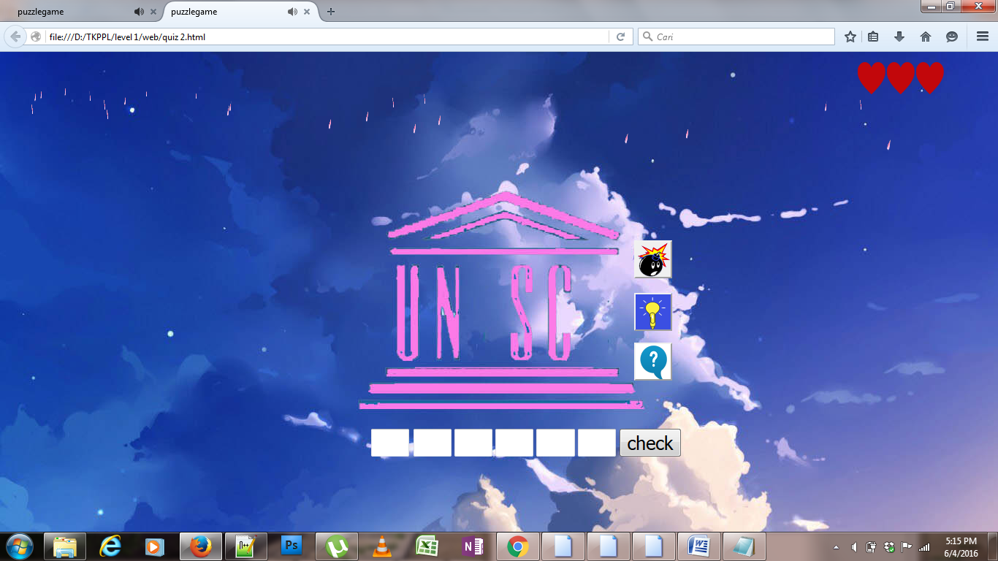

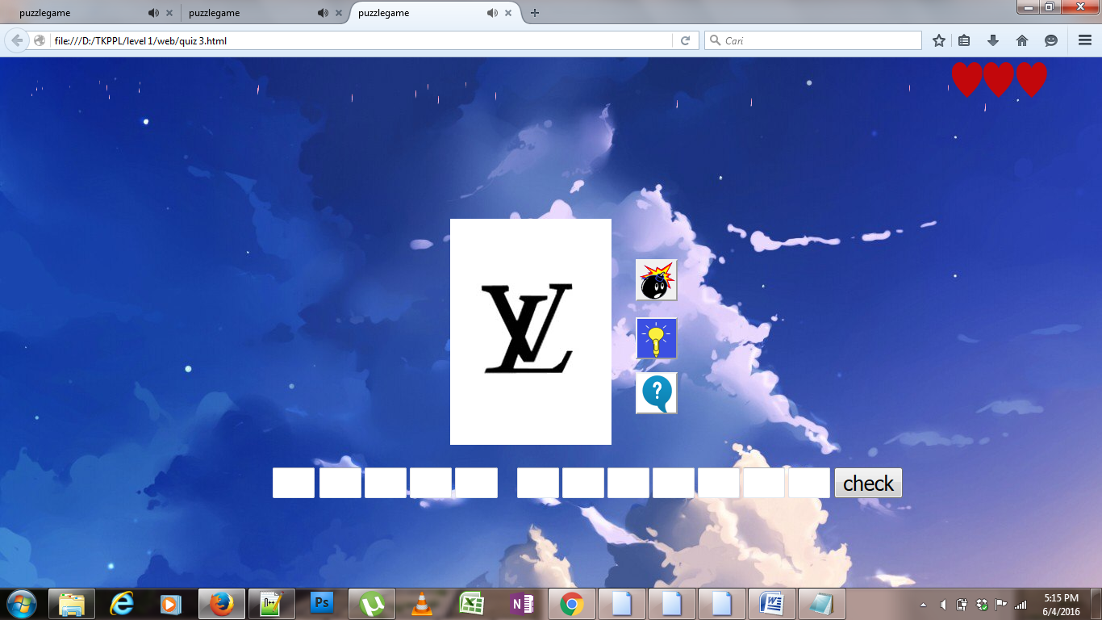

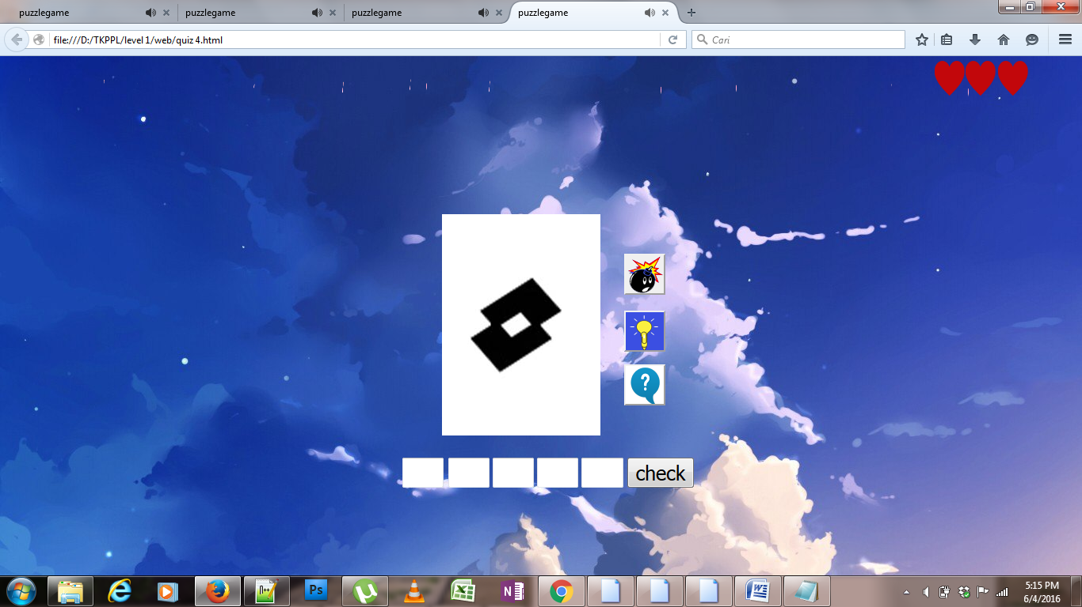

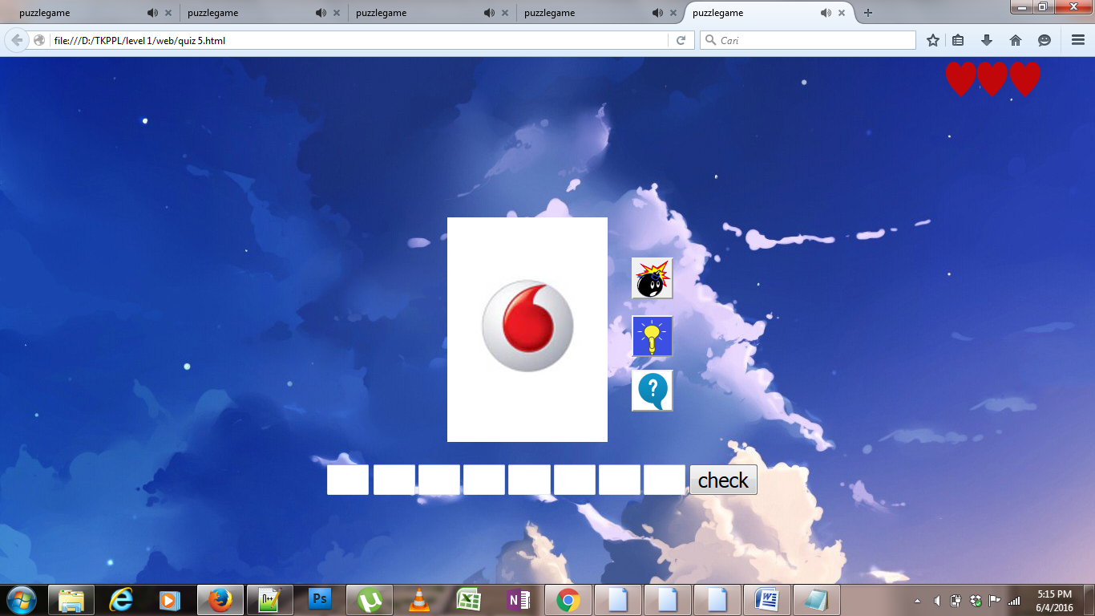

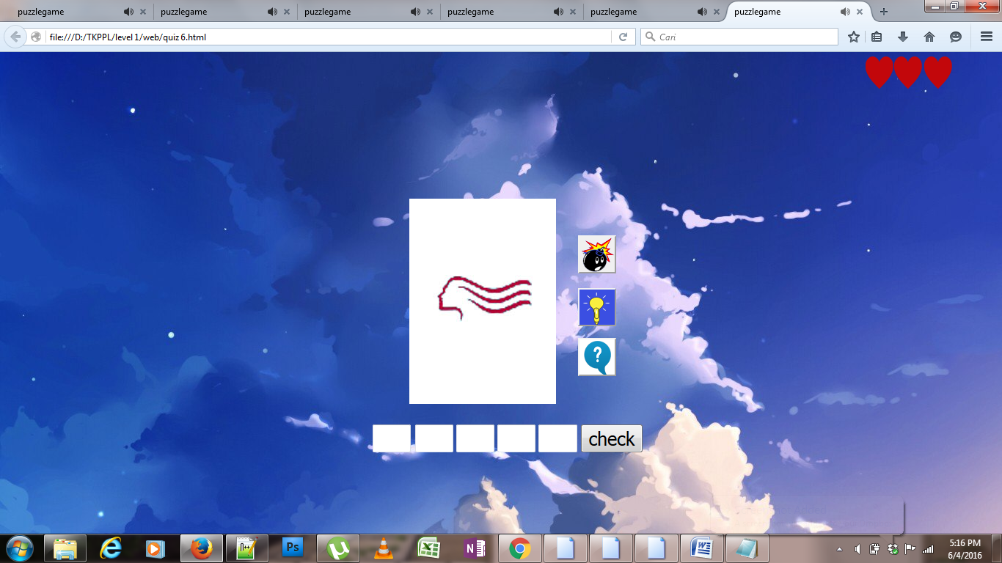

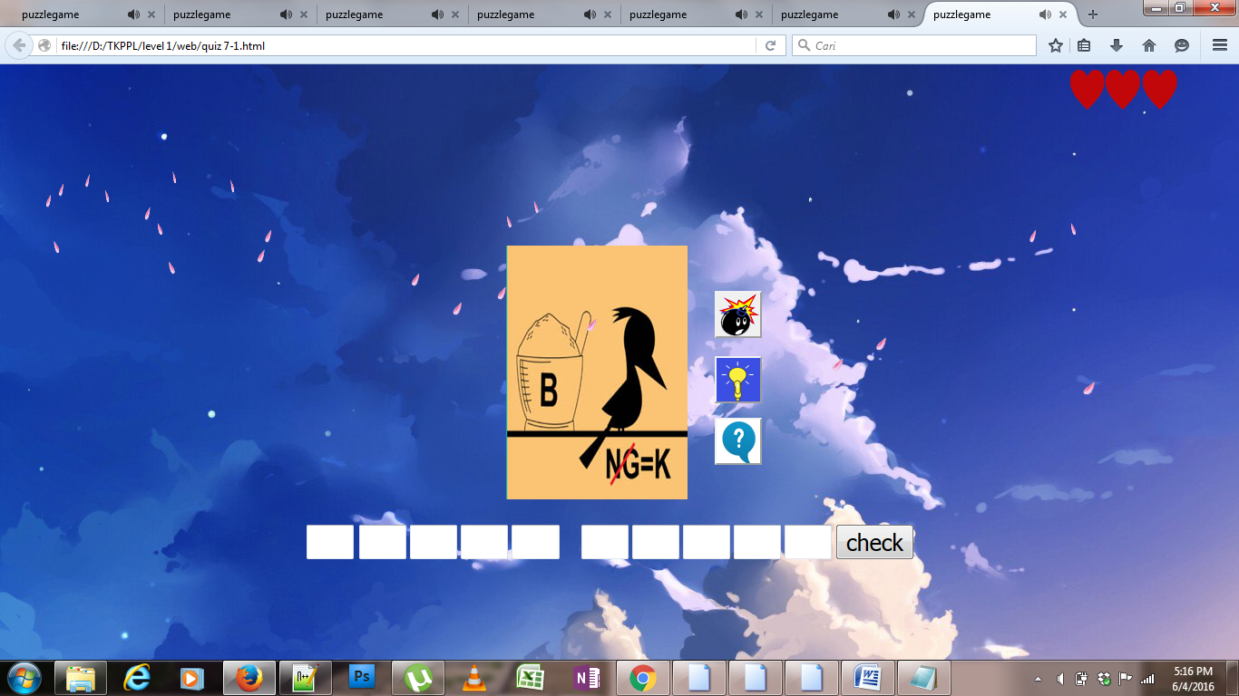

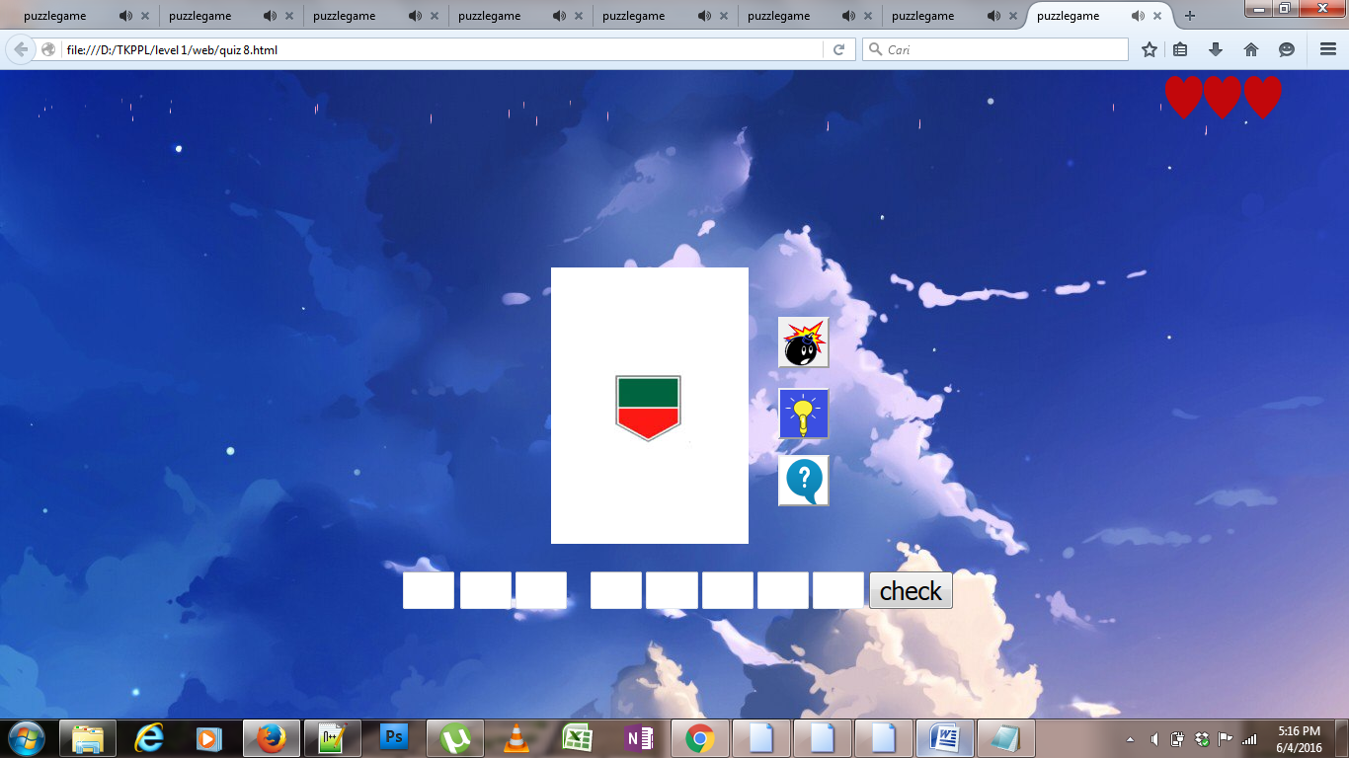

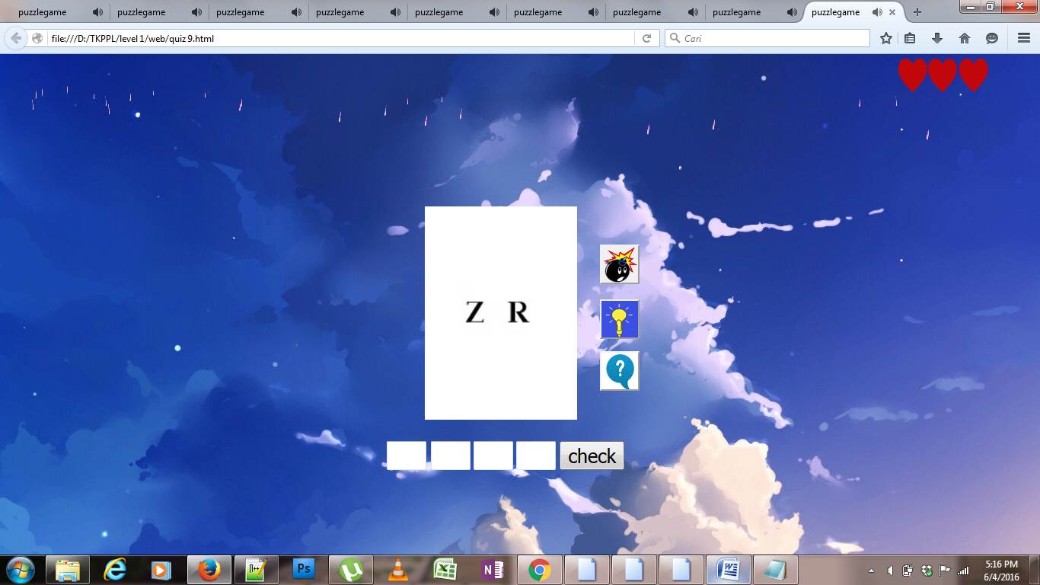

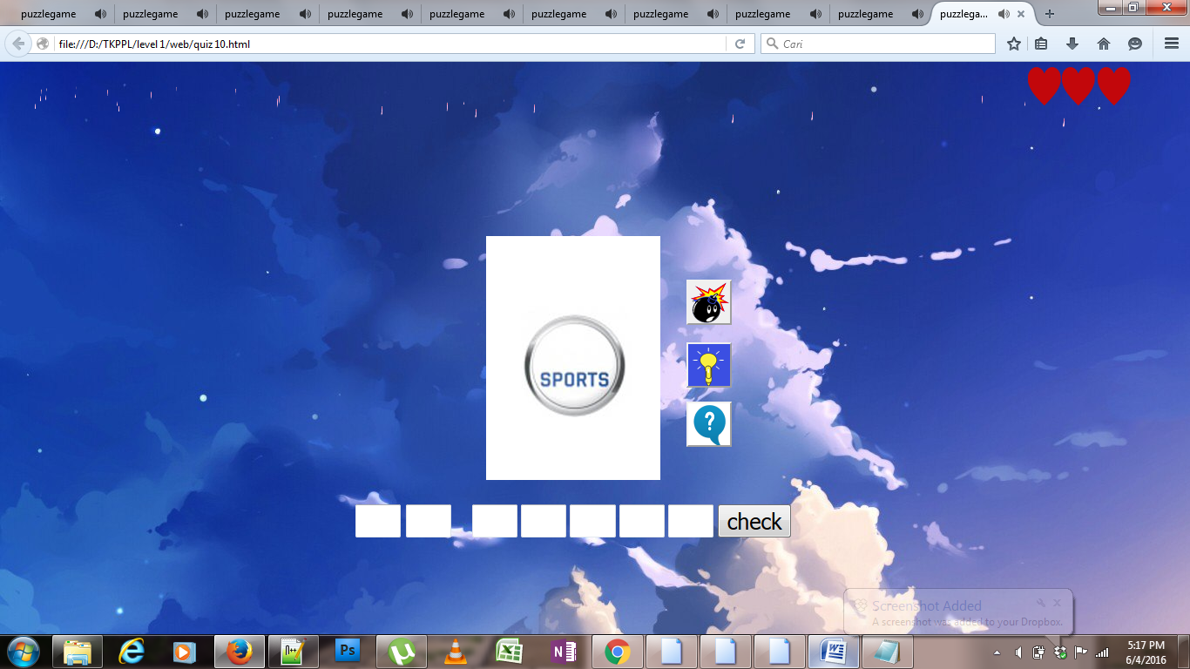berikut gambar diatas codenya semuanya sama ,hanya tinggal menggubah gambar saja ,dari code yang pertama

Jika salah tulis maka akan seperti gambar dibawah ini:

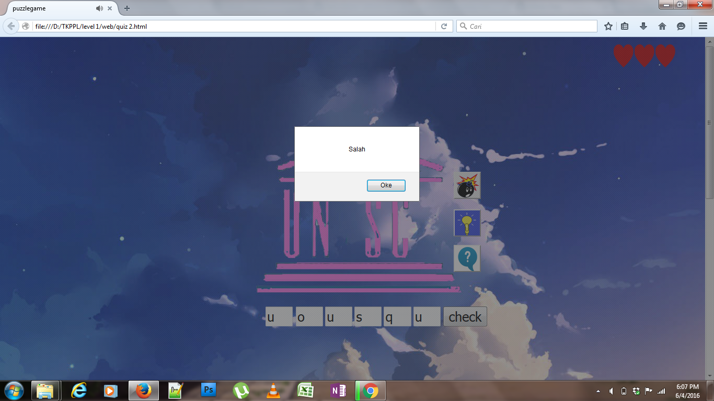

Selanjutnya semua tulisan hilang

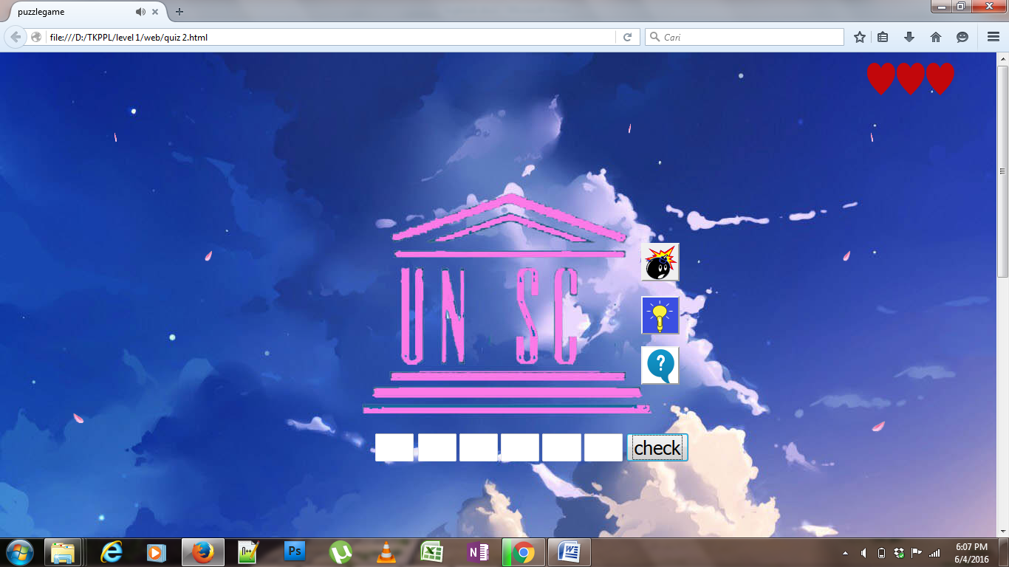

Menggunakan hint pertama:

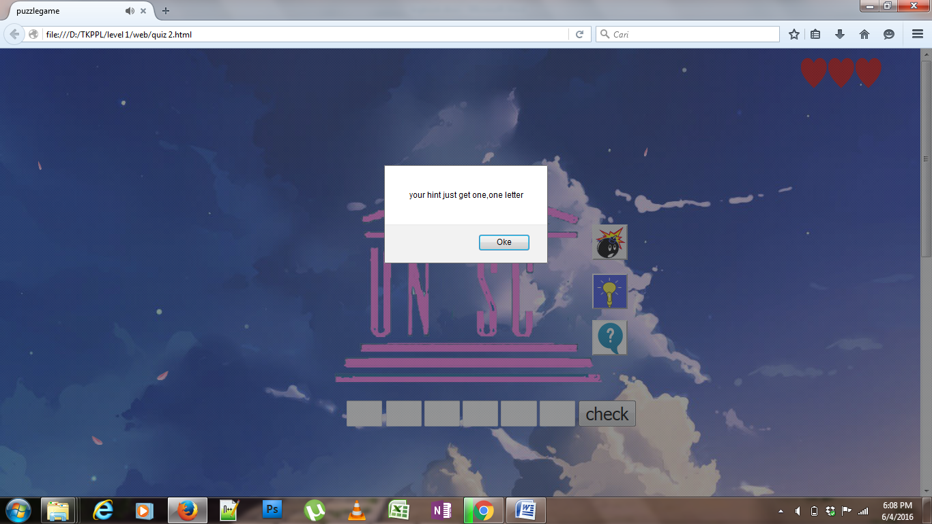

Nyawa 1 hilang ketika menggunakan hint pertama

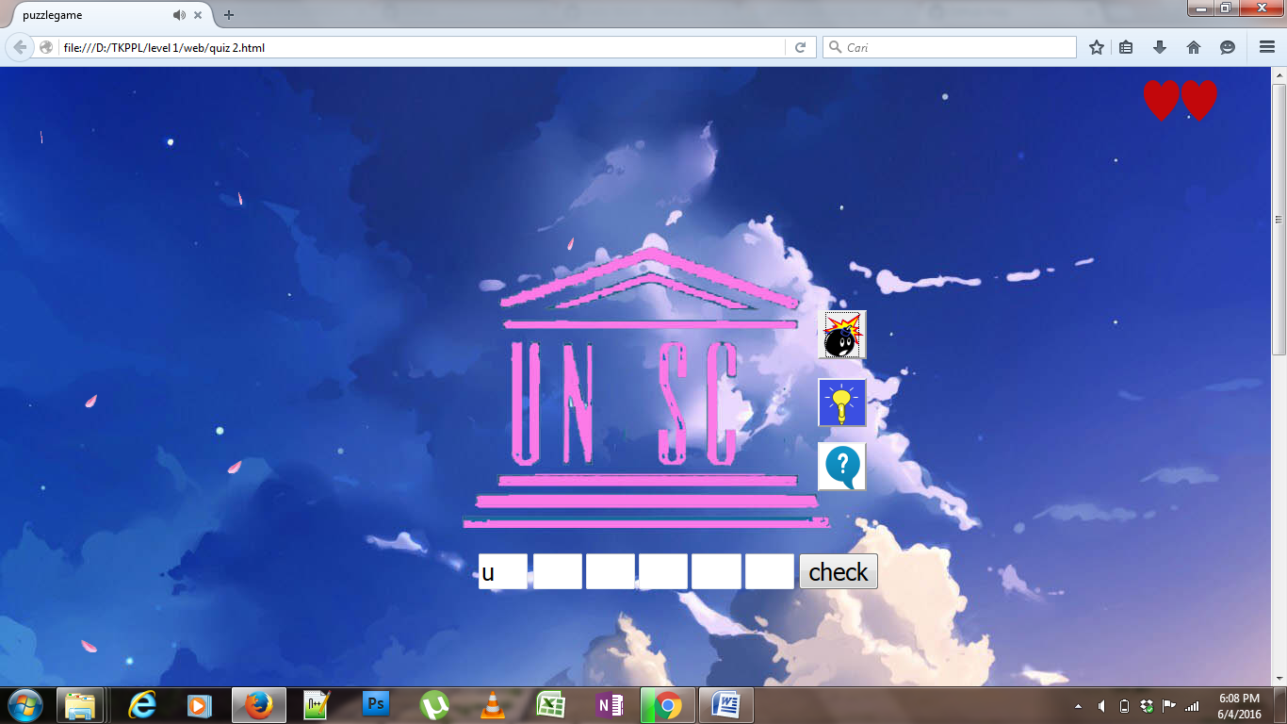

Nyawa 2 hilang ketika menggunakan hint kedua

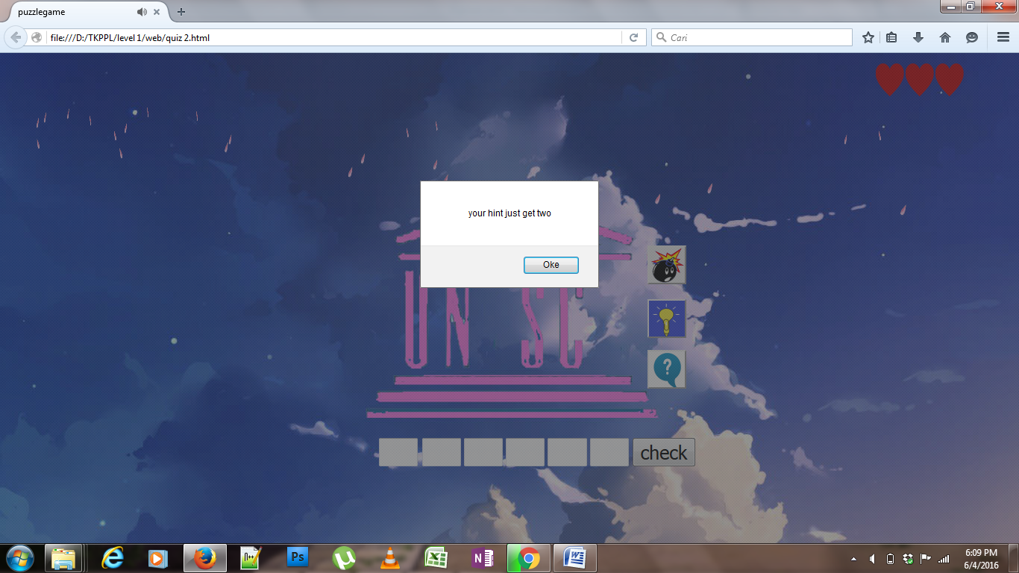

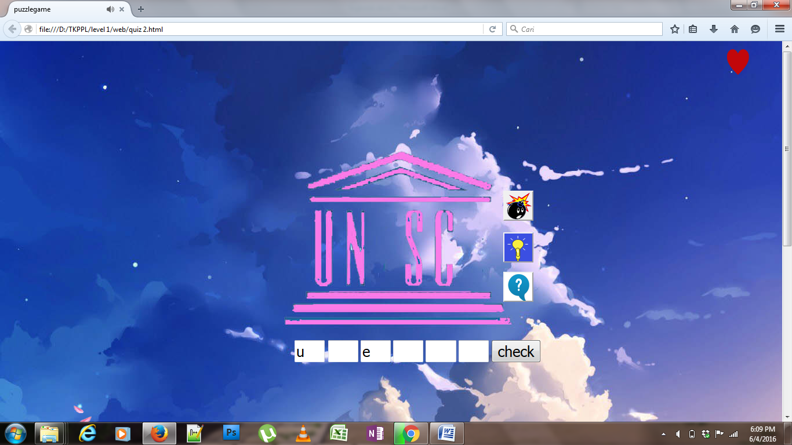

Nyawa hilang semua dan game over dan akan kembali ke halaman stage

